VIRTUAL LAB

**Aim:**

1. Implementation of 4 bit Up Counter using JK Flip flop.
2. Implementation of 4 bit Down Counter using T Flip flop
3. Design and Implementation of MOD 20 Counter using T Flip flop

**Software Used:** Logisim Software.

**Design And Implementation:**

1. **4 bit Up Counter**:

Excitation Table:

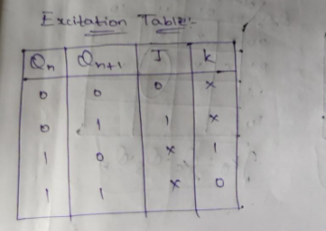

Transition Table:

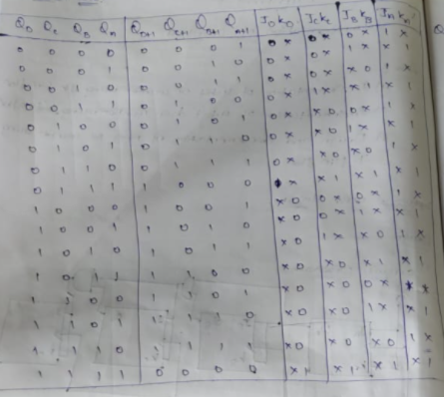

K-Map:

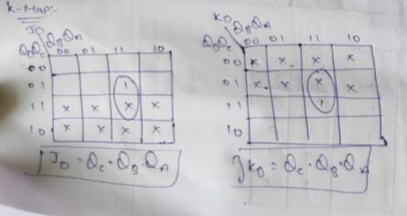

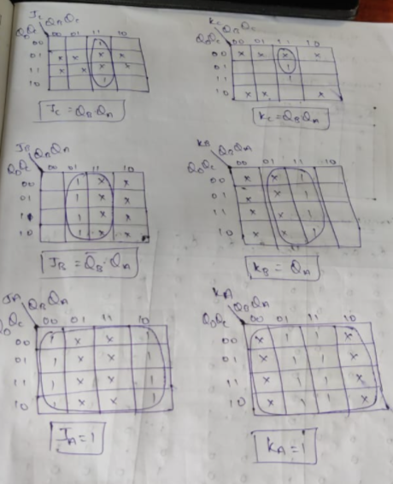

Circuit Diagram:

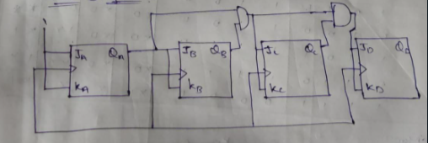

Software Implementation:

21MIS1128 T.Akash Reddy


21MIS1128 T.Akash Reddy

1. **4 bit Down Counter:**

Excitation Table:

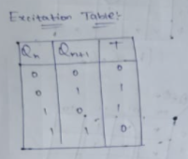

Transition Table:

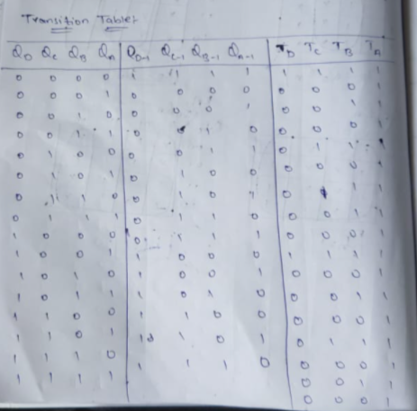

K-Map:

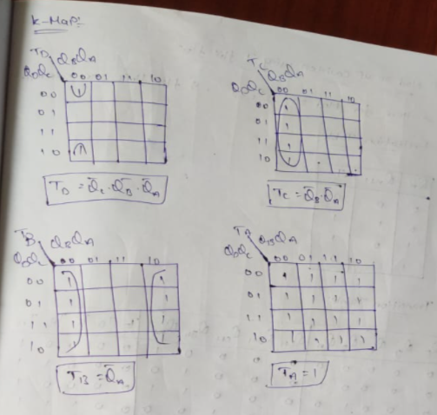

Circuit Diagram:

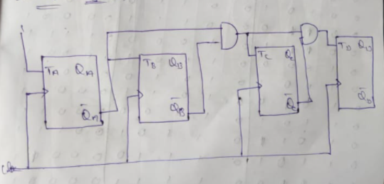

Software Implementation:

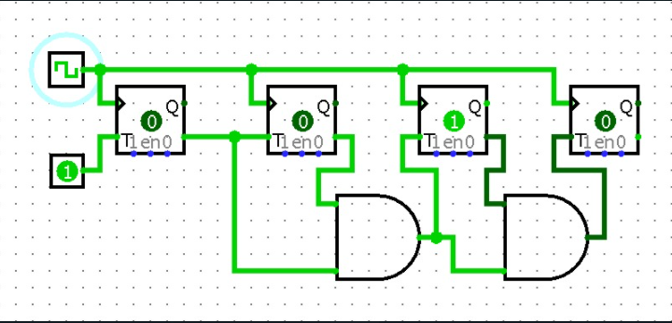

21MIS1128 T.Akash Reddy

1. Mod 20 UP counter:

Excitation Table:

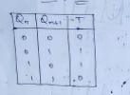

Transition Table:

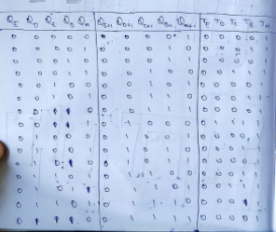

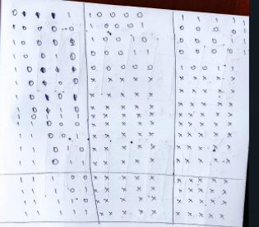

K-Map:

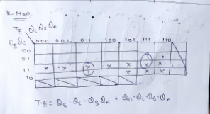

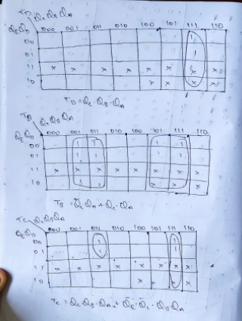

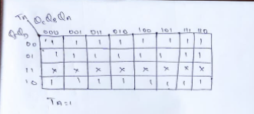

Software Implementation:

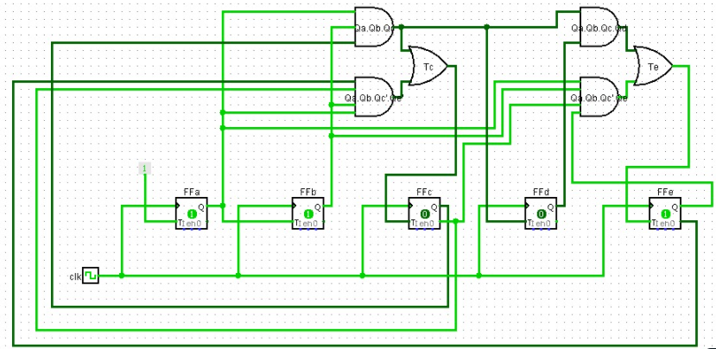

21MIS1128 T.Akash Reddy